Spring Microservices

Pre-requisites

* Core Java – OOPS & Design pattern (Factory pattern)
* Comparator & Lambda expressions
* Java 8 Streams – stream(), forEach(), filter(), collect(), sorted()
* Spring Framework – Dependency Injection & Annotations
* Spring Boot – Webservices & Configurations

Factory Design pattern

It is to abstract object creation at the client side

interface DBOperations {   
 void store();  
 void delete();  
}

class One implements DBOperations { }   
class Two implements DBOperations { }  
class Three implements DBOperations { }

Scenario1: Client creates object – leads to tightly coupled code

DBOperations db = new One(); // if new implementation must be used, then code must be modified here  
db.store();  
db.delete();

Scenario2: Client doesn’t create object – they use factory pattern to get the object – makes code loosely coupled

class DBFactory {   
 public static DBOperations getInstance() {   
 return new Two();  
 }  
}

DBOperations db = DBFactory.getInstance(); // client doesn’t know which implementation object is returned.  
db.store();  
db.delete();

DBOperations.java

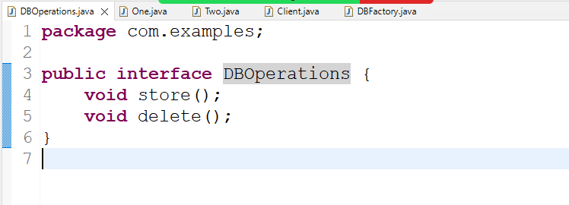

One.java

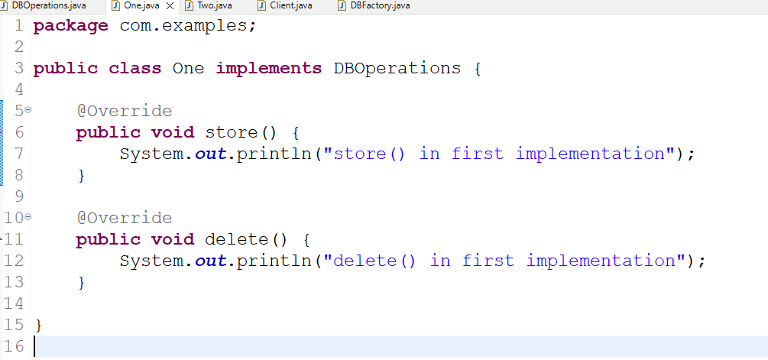

Two.java

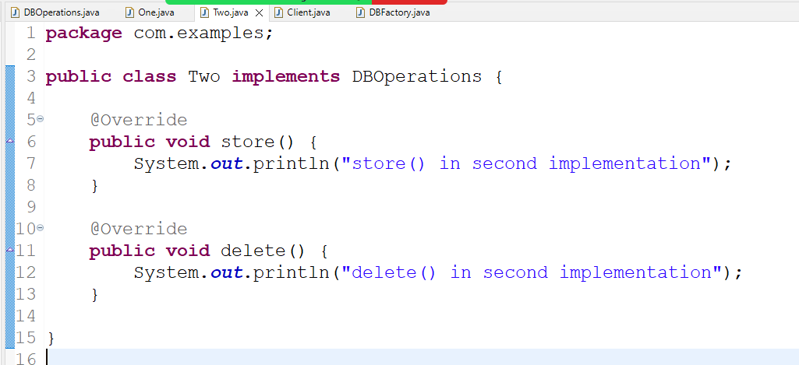

DBFactory.java

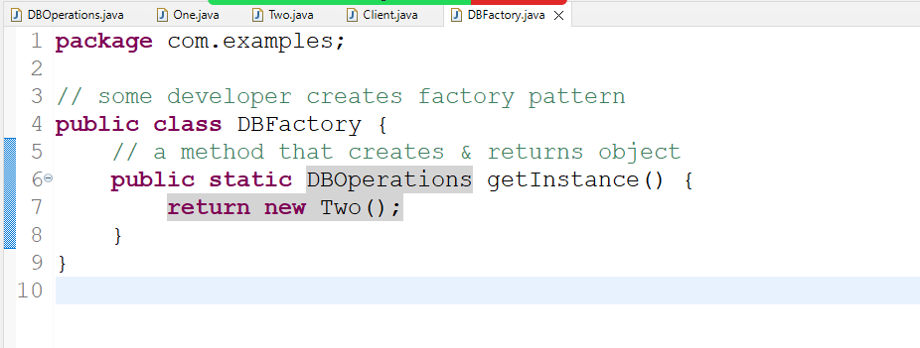

Client.java

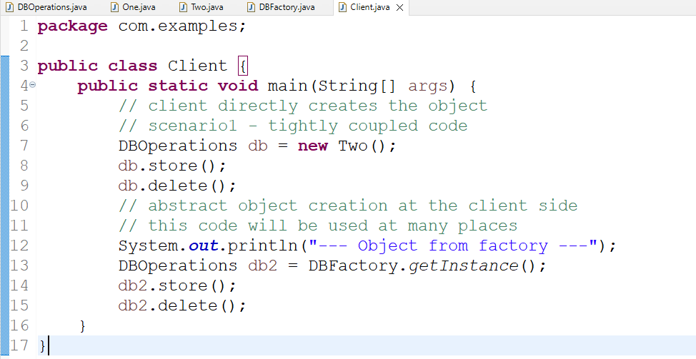

Output:

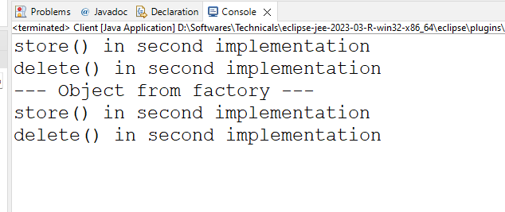

Summary:

Developers who create object directly need to change their code when a new implementation needs to be used, developers who gets the object from the factory pattern need not to change the code because factory pattern takes care of giving the object.

Factory pattern vs Singleton pattern

Factory pattern just creates the object, however singleton pattern is a factory pattern where on a class only one object will be created even if you call the factory method more than once

Previous factory pattern creates object more than once based on the how many time you call the getInstance() factory method, this leads to more number of object creation, to avoid this we can change the factory method to give only one object regardless of how many times you call the factory method

Modifying the factory to return a singleton object

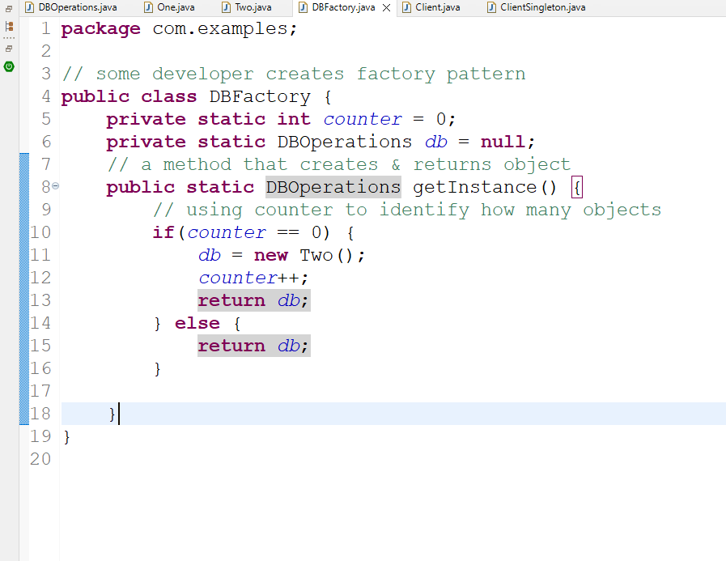

ClientSingleton.java

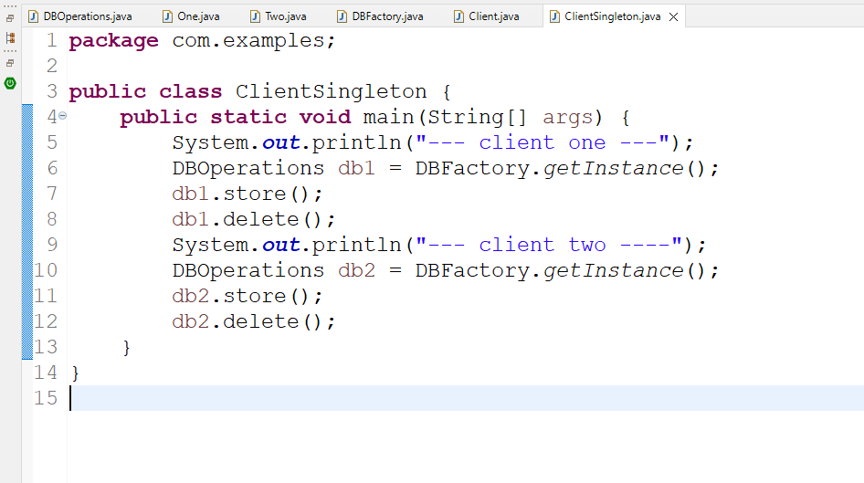

Spring Framework:

Framework is like a semi implemented application which provides all the common features every application needs like

1. Type conversion: String to Number to String & Java types to SQL & vice versa
2. Design patterns:
3. Object Creation & Initialization
4. Exception Handling
5. Transaction Management
6. Connection Pooling

Spring Framework is an application framework which helps you to create various types of applications

1. Web / Webservices
2. Desktop
3. Cloud based application
4. Console based application

Spring Framework provides many modules to develop the above applications

1. Spring Core
2. Spring Web
3. Spring Boot
4. Spring Cloud
5. Spring Batch

Spring Core: It is the base modules that takes care of all the features every application needs like

1. Design pattern
2. Object creation

Dependency Injection: It is a process of supplying an object to another object

Spring framework uses factory pattern internally to create objects so that developers don’t have to implement factory pattern

Spring Context: This is the library which you need to use to get the benefits of spring framework for Dependency Injection

pom.xml

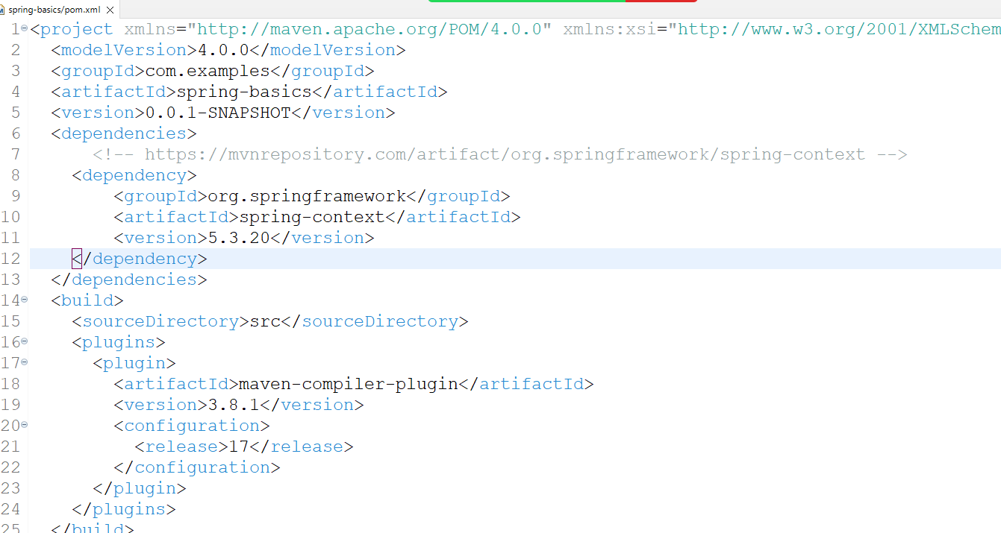

Project Structure

1. classes
2. XML – declare all the beans (java classes) whose object must be created by spring container

Identifier.java

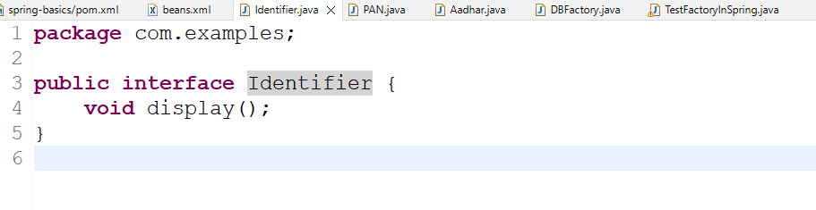

PAN.java

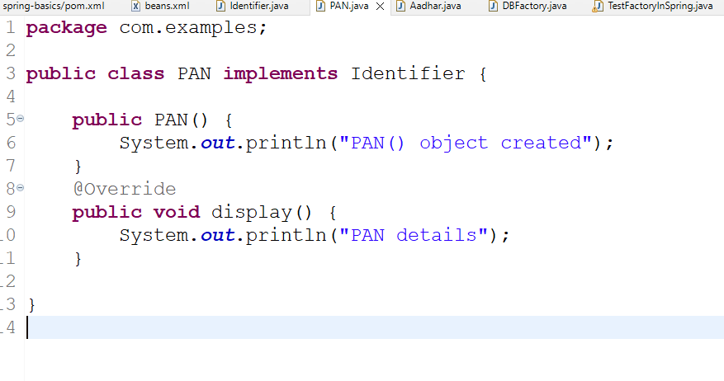

Aadhar.java

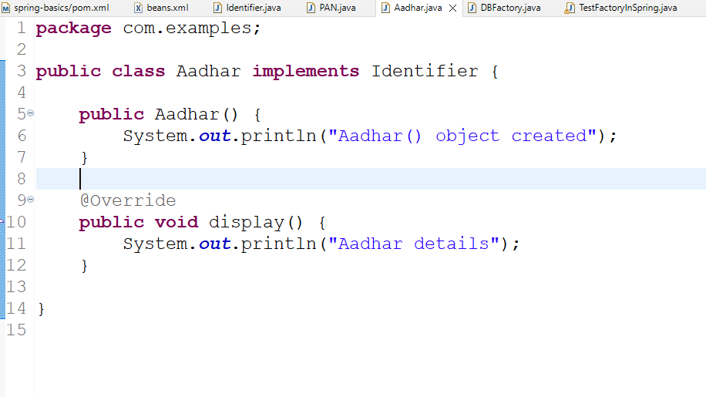

beans.xml

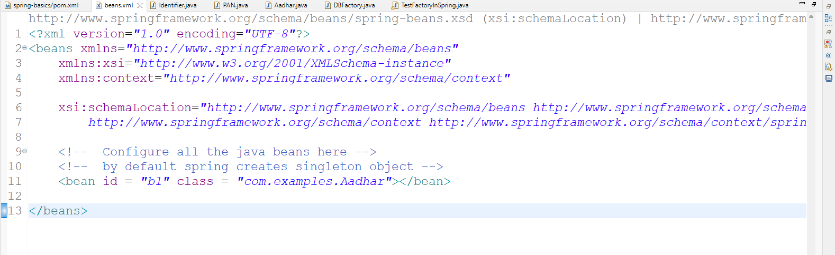

TestFactoryInSpring.java

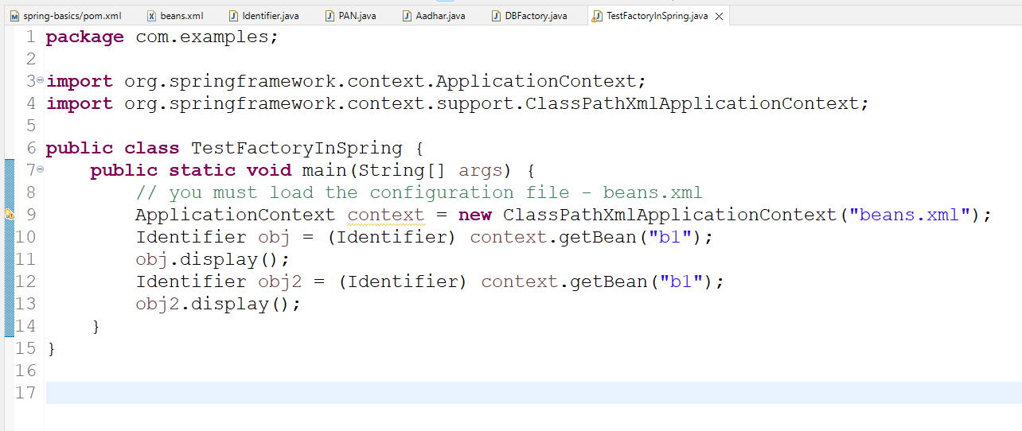

Note: At present spring container is creating singleton object, but you can make it to create multiple objects, for that you must use scope in the xml

beans.xml

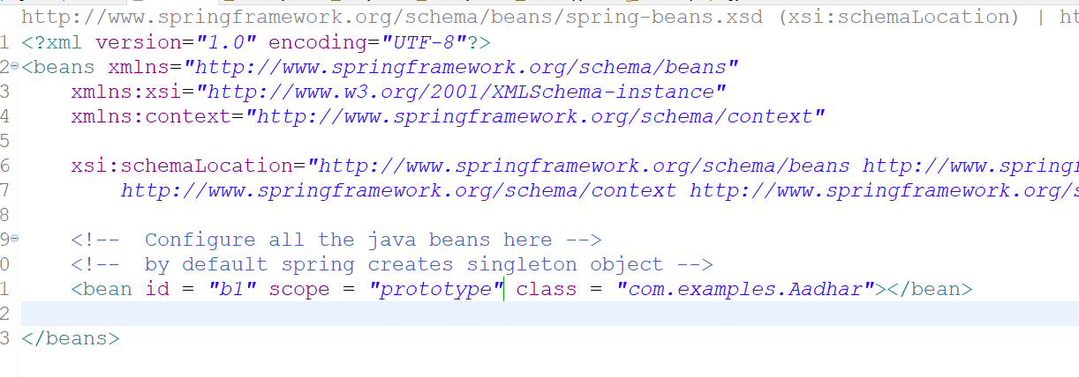

scope is singleton by default, when it is prototype spring creates multiple objects for each getBean() invocation.

Output:

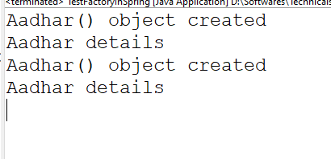

Annotation based configuration

It simplifies configuring the spring beans with simple annotations so that you can avoid declaring beans in the XML file

List of annotations spring provides to create the object

@Component  
@Service  
@Repository  
@RestController

@Service  
public class EmployeeService { } // id will be class name but first letter will be lowercase

This is equal to <bean id = “employeeService” class = “com.examples.EmployeeService”>

@Repository  
public class EmployeeDao { }   
This is equal to <bean id = “employeeDao” class = “com.examples.EmployeeDao”>

@Component is a base annotation where as @Service, @Repository, @RestController, @Configuration, @Controller are all derived from @Component

Note: If spring needs to search the classes having these annotation then in XML you need to use one tag to scan all the classes having these annotation

<context: component-scan base-package = “com.examples” />

beans.xml

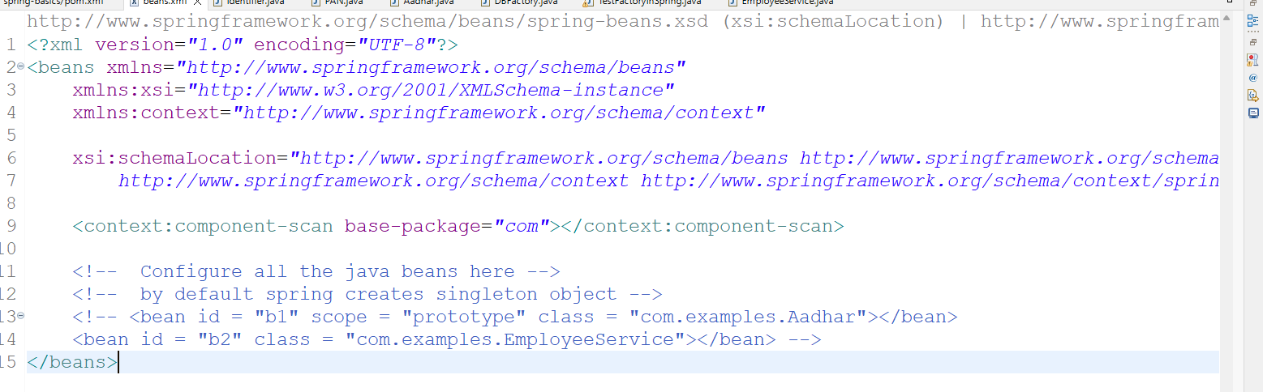

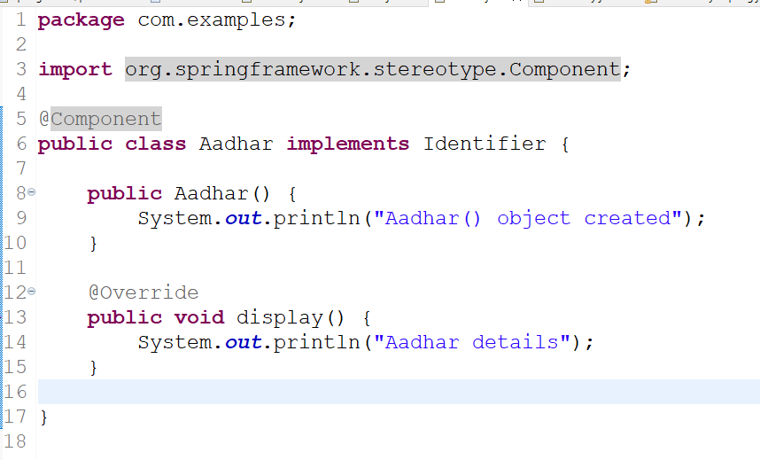

EmployeeService.java

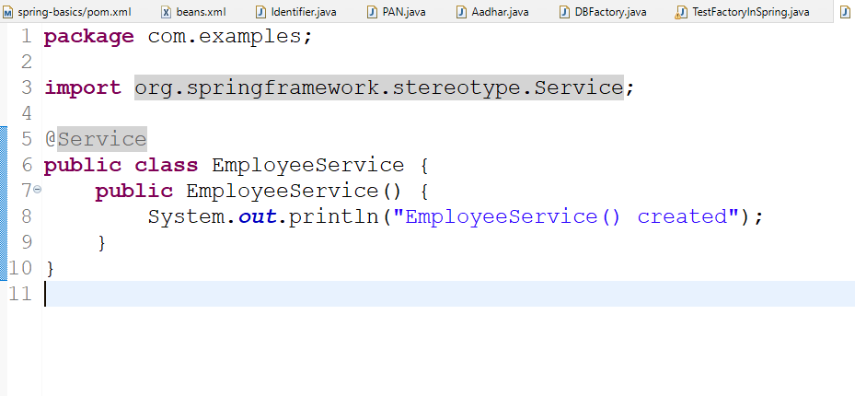

TestFactoryInSpring.java

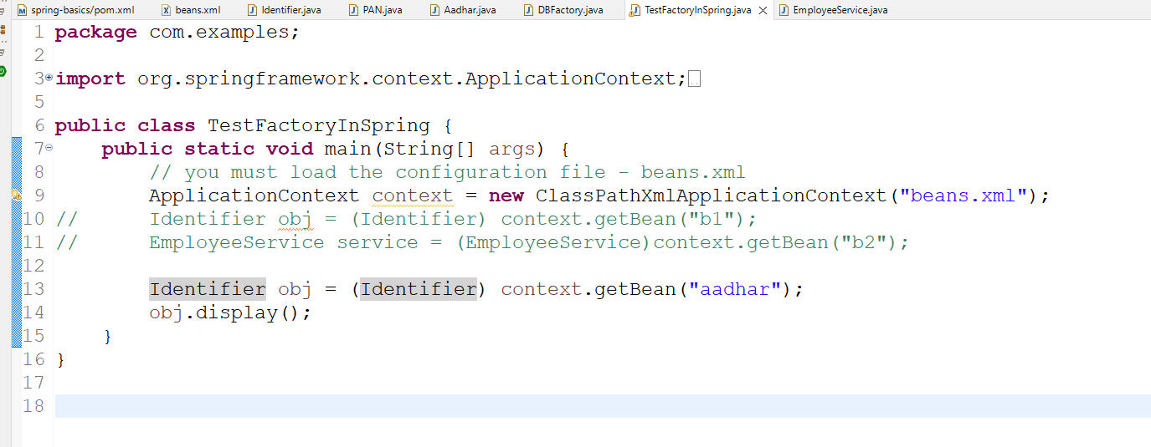

Output:

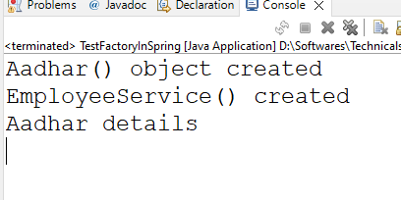

Spring is going to scan all the classes having @Component or their derived annotations to create the object.

Spring Boot

It simplifies developing the spring applications by auto-configuring your application based on the library you add

Spring boot takes care of configuring all the generic setup

* Server configurations
* Database configuration
* Component scanning
* Front controller configuration

Spring boot does this using the libraries which will have name as spring boot starter

ex: spring boot starter web, spring boot data jpa,

spring initializr: it is a official website to download empty spring boot project

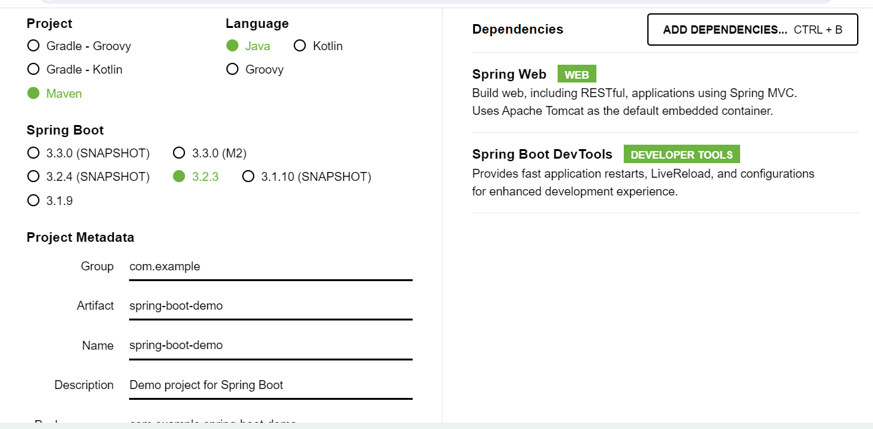

When you download you will get a zip file, which you can directly open from eclipse, by following these steps

File -> Open Projects from file system -> In Import Source -> Archive -> zip file -> Select maven project & uncheck the folder not having maven

Every project of spring boot will have a main class with @SpringBootApplication that does the following job which is mentioned in the comments

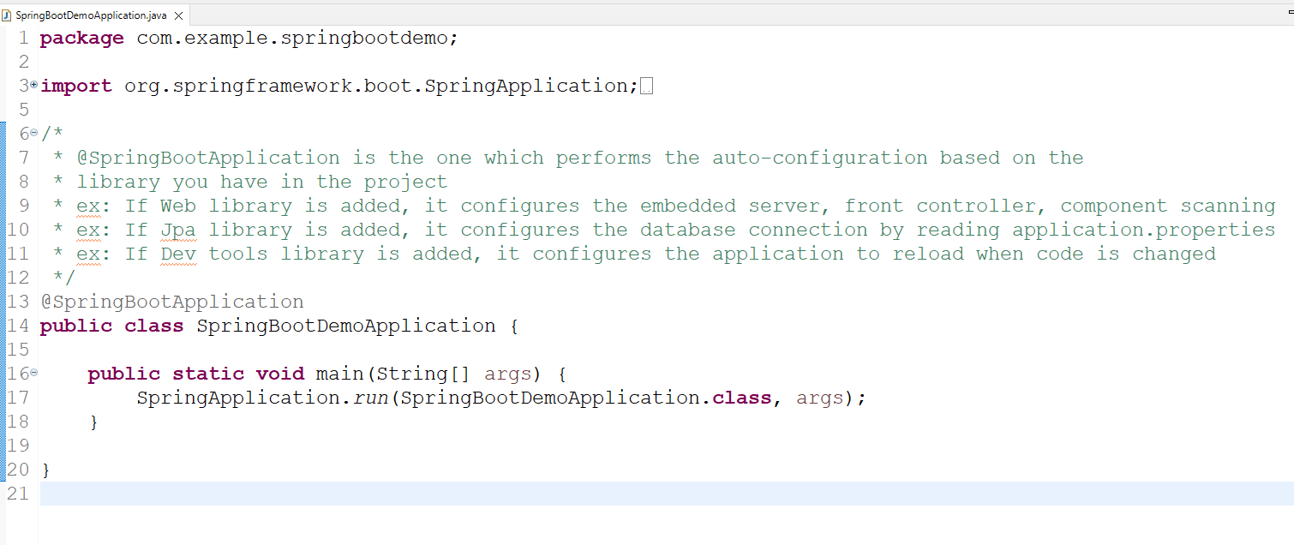

You can get all the properties of spring boot in the below URL

<https://docs.spring.io/spring-boot/docs/current/reference/html/application-properties.html#appendix.application-properties.data>

application.properties

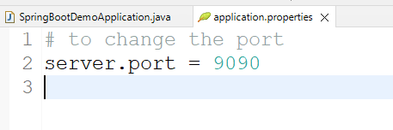

Webservices:

These are online services that helps heterogenous applications to share the data

ReSTful webservice exchanges the data in a common format (JSON)

ReST stands for Representational State Transfer

ReSTful uses two things to allow applications to exchange the data

1. URL: To locate the webservices
2. HTTP methods: To map the operations using GET, POST, PUT & DELETE

To create webservices in Spring we have some annotations

1. @RestController: This is to create a controller class which will have webservice code
2. @RequestMapping: This is to configure the URL for your controller
3. @GetMapping: This is to map HTTP GET
4. @PostMapping: This is to map HTTP POST
5. @PutMapping: This maps HTTP PUT
6. @DeleteMapping: This maps HTTP DELETE

@RestController  
@RequestMapping(“/api/profile”)

class ProfileController {   
 @GetMapping(path = “/test”)  
 public ResponseEntity test() {   
 return ResponseEntity.status(200).body(“some data”);  
 }  
}

Client uses: GET http://ip:port/api/profile/test

ProfileController.java

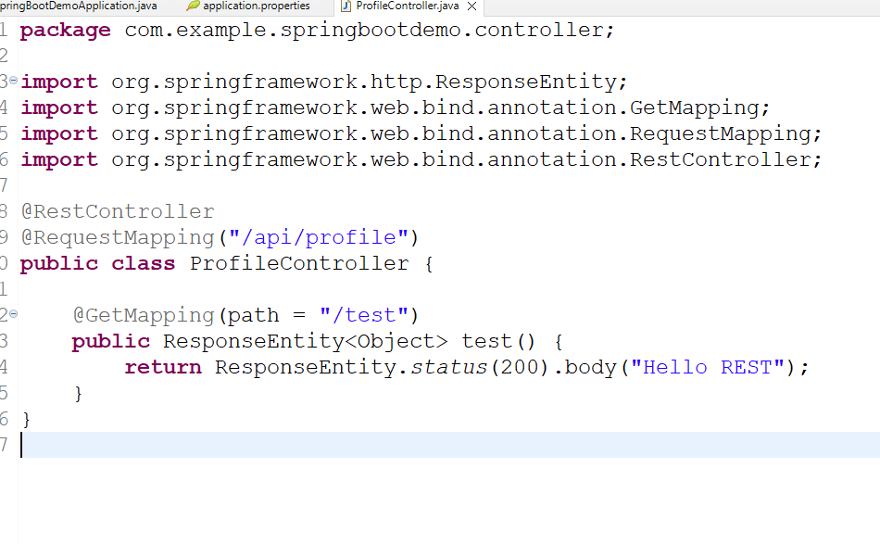

Output:

